Task 2.2: Adding Style to the Webpages Using CSS
Overview
In this Touchstone task, you will create an external CSS file to add styling and colors to the HTML pages. The component colors, font colors, and typography styling should be consistent with your choices in Task 1 and should be appropriate according to the client description provided in the Client Scenario and Criteria. The majority of the styling should be incorporated using an external CSS file. Inline and/or internal CSS styling can only be used when needed but should be minimal. Document any issues or errors you encounter in your code development that prevent your stylesheet or webpages from functioning as intended.
Instructions
Provide your responses in the following table.
Rendered Homepage Screenshot
Hint: Provide the screenshot for the rendered Homepage.
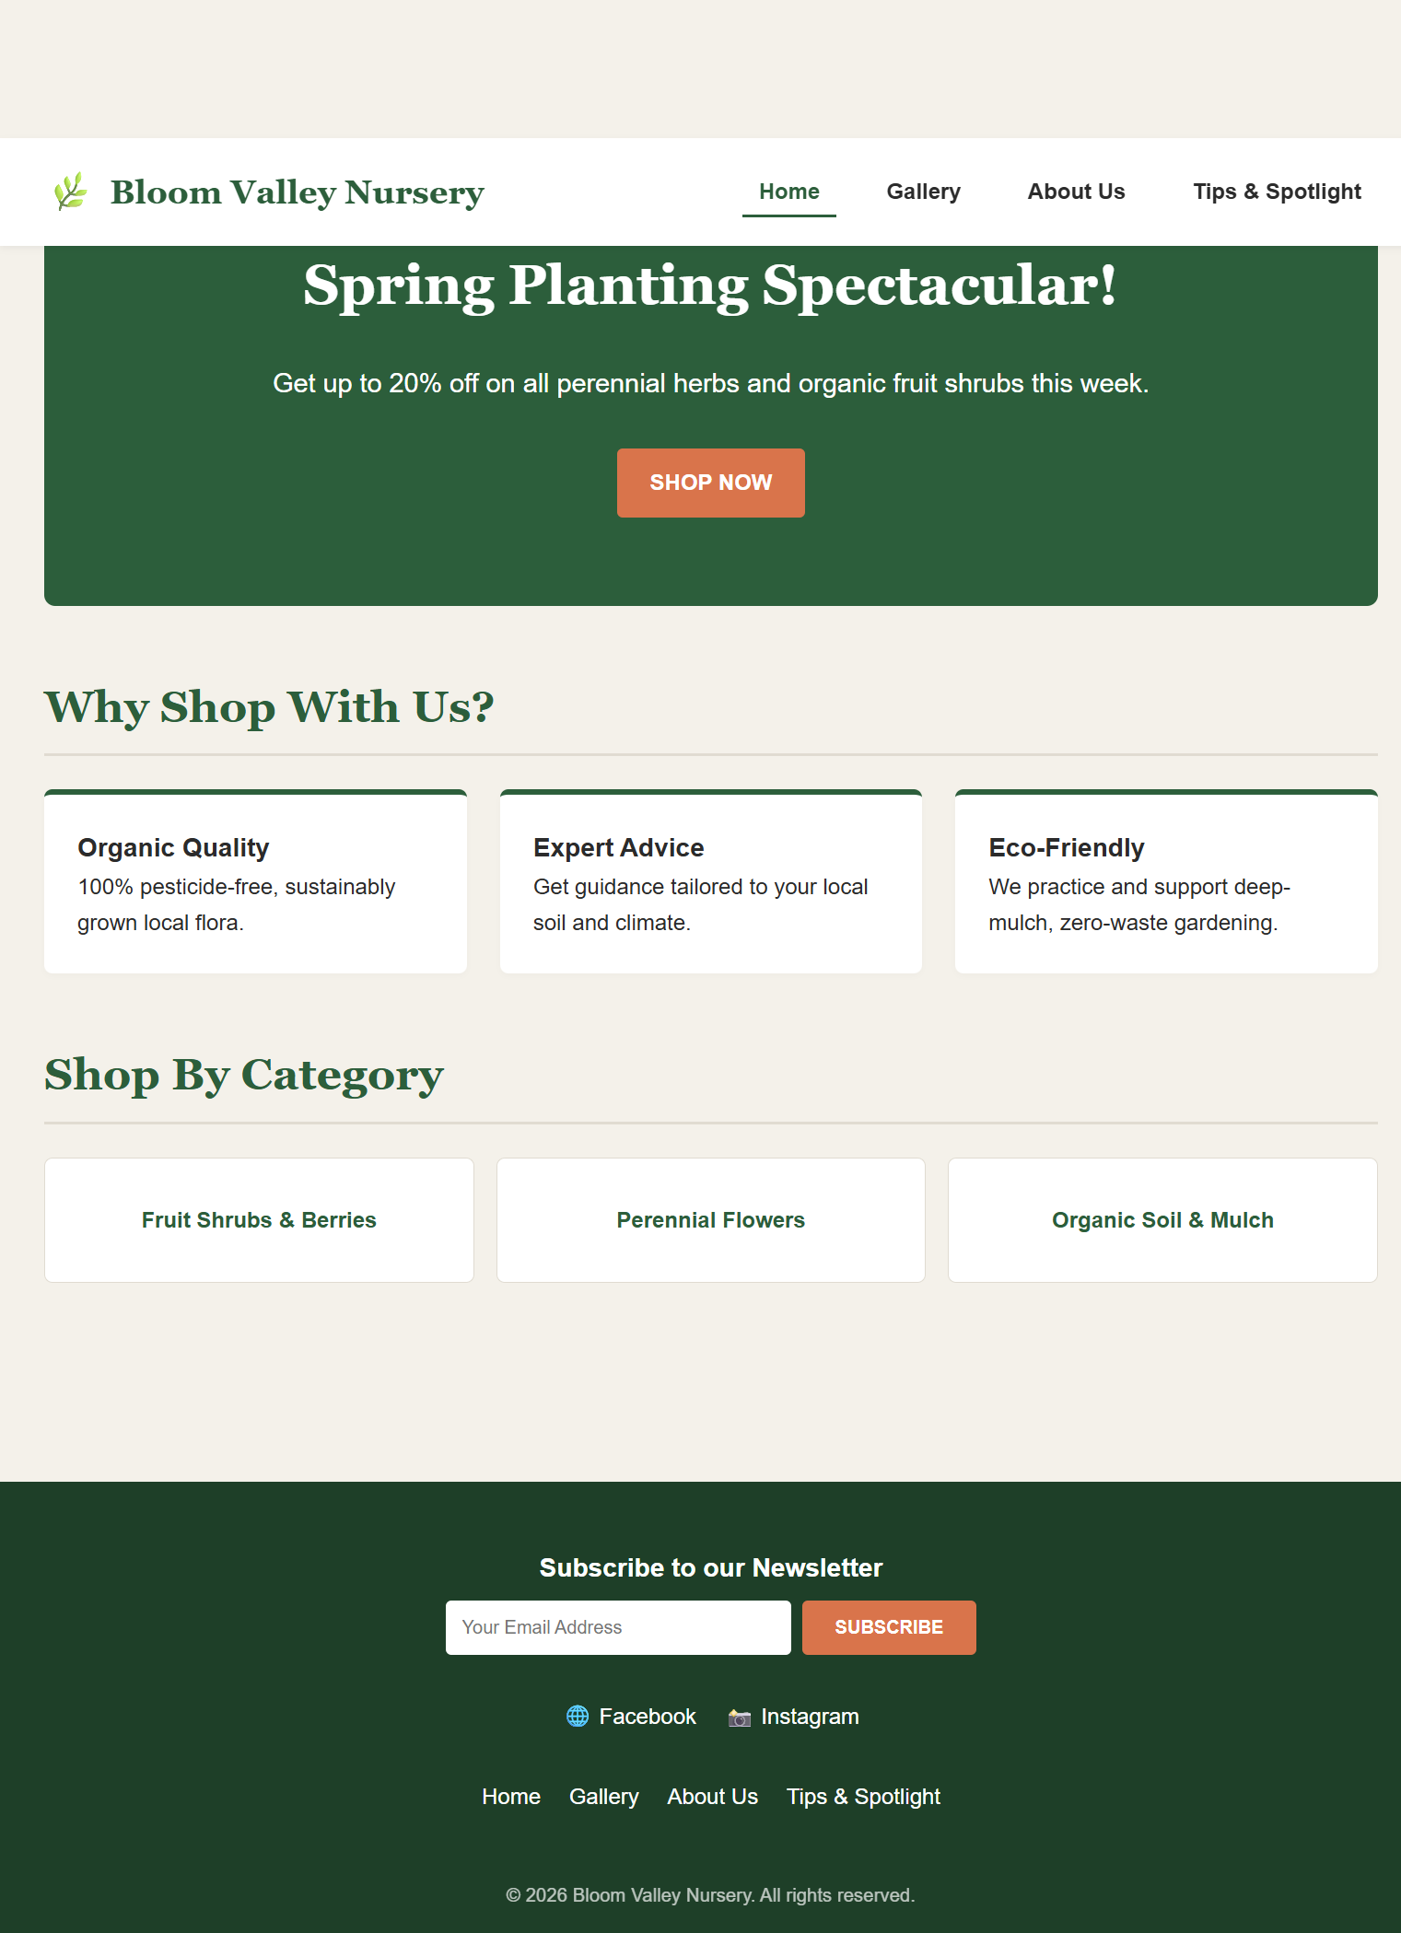

Homepage Analysis
Hint: Provide a brief description about the rationale of the CSS styling in the Homepage.
The homepage layout uses clean CSS structural design to establish a welcoming storefront. The typography implements Garamond for the primary brand identity and Comfortaa for modern, legible subheadings and structural sections, as planned in Task 1. We utilized a natural and organic color palette—incorporating soft cream backgrounds, deep botanical greens for section divisions, and dark charcoal text for high contrast. Flexbox was applied to the global header and navigation layout to align elements evenly across the layout.

Rendered Gallery Page Screenshot
Hint: Provide the screenshot for the rendered Gallery page.
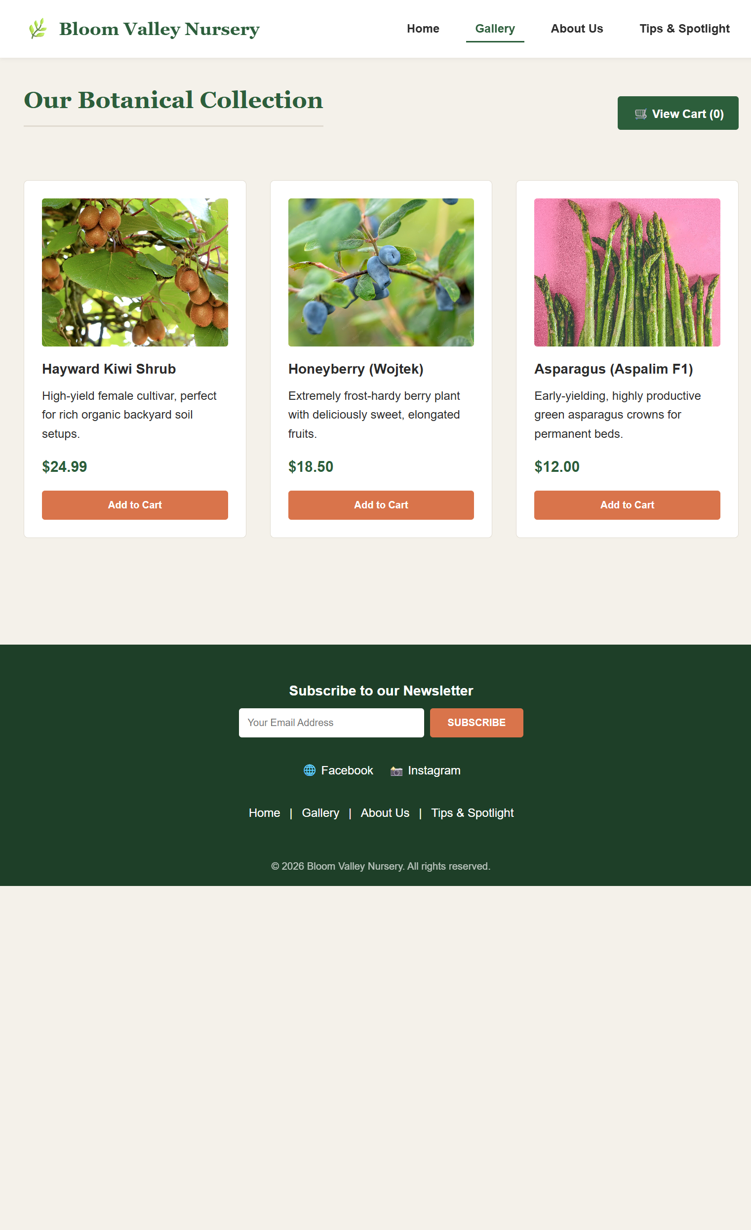

Gallery Page Analysis
Hint: Provide a brief description about the rationale of the CSS styling in the Gallery page.
On the Gallery page, CSS styling was heavily focused on structured alignment and clear product formatting. The HTML table component was styled to remove default borders, adding clean padding and balanced margins around each cell. Product placeholders are uniformly sized with consistent borders to match the wireframe template. Buttons labeled 'Add to Cart' are styled with distinct background fills, hover transitions, and rounded corners to draw user attention and create an intuitive interactive e-commerce grid.

Rendered About Us/Contact Page Screenshot
Hint: Provide the screenshot for the rendered About Us/Contact page.
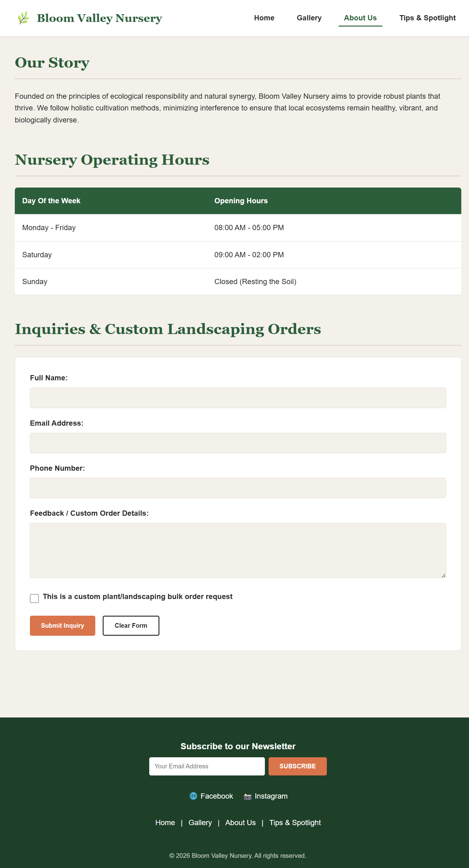

About Us/Contact Page Analysis
Hint: Provide a brief description about the rationale of the CSS styling in the About Us/Contact page.
The About Us and Contact page focuses on functional information hierarchies and interactive form presentation. The user feedback and custom order form elements were styled using explicit block-level layouts. Inputs, textareas, and checkboxes include explicit width controls, internal padding, subtle borders, and smooth focus indicators to enhance data-entry clarity. The submit button is visually highlighted using a primary green accent to incentivize user interaction.

Rendered Custom Page Screenshot
Hint: Provide the screenshot for the rendered custom page.
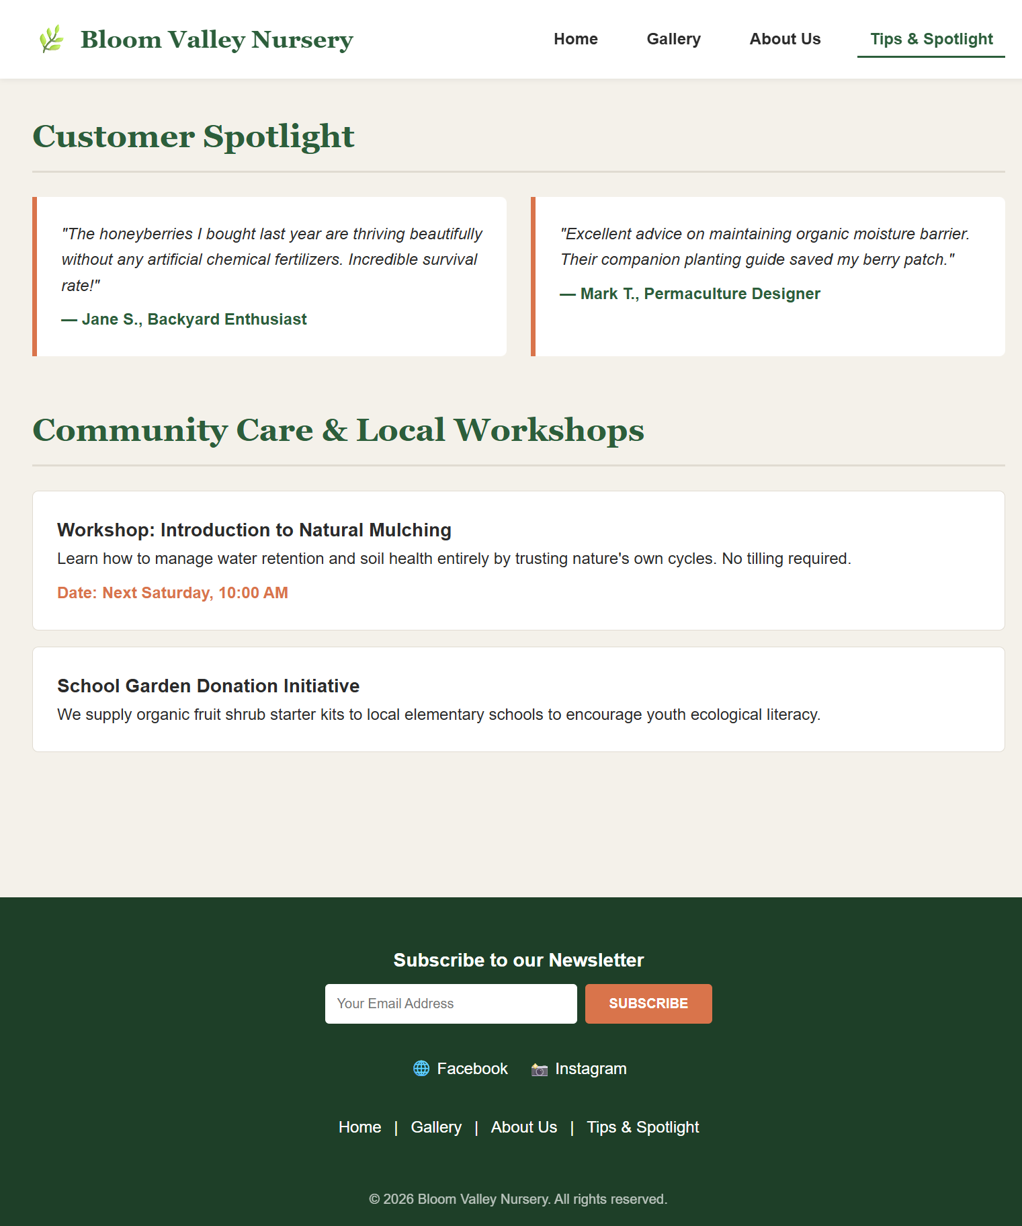

Custom Page Analysis
Hint: Provide a brief description about the rationale of the CSS styling in the custom page.
The custom page integrates social proof elements into a clean, multi-column presentation layout. The 'Customer Spotlight' testimonial containers and 'Community Care' boxes utilize card-style layout components. These are styled with consistent background variations and structural padding to separate individual quotes from background informational blocks, keeping a unified visual language with the rest of the application.

Accessibility Analysis
Hint: Provide a brief description of how accessibility practices were followed on the website.
- Color Contrast: All structural text layouts strictly adhere to WCAG AA accessibility standards, maintaining a contrast ratio above $4.5:1$ by deploying deep forest greens and charcoal dark text against light cream background structures.
- Semantic Layout Elements: The structure relies fully on native semantic elements (<header>, <nav>, <main>, <section>, <footer>) ensuring assistive screen readers can interpret page hierarchies effortlessly.
- Form Labelling and Focus: All input controls within the custom order form have explicit semantic text labels, and CSS :focus indicators are defined to support purely keyboard-driven navigation path highlights.

Responsive Web Design Analysis
Hint: Provide a brief description about how to adjust the website to be responsive for the mobile platform.
To transform the desktop webpage structure into a fully responsive mobile platform interface, we utilize CSS Media Queries tailored for viewport break-points under 768px. The primary architectural adaptation involves transitioning multi-column desktop grids into a single-column block system. For example, the 4-column inline navigation bar converts into a vertically stacked drop-down mobile menu element. In the Gallery, the multi-row table cells wrap dynamically into a vertical, stack-based timeline card system, ensuring full layout readability on narrow mobile viewports without horizontal scrolling.

Testing and Error Reporting
Hint: While writing and testing your code, record any errors, and state your approach to fixing the errors. Did the outcome look the way you expected? Did you find anything particularly difficult to accomplish?
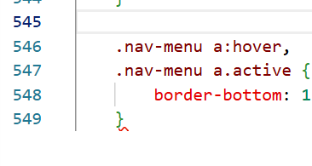
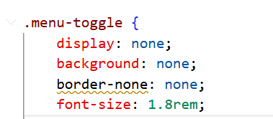
- I forgot to close the @media section at the end. Later did it.
- Used the non-existing „border-none: none;”, corrected it to „border: none;”

